
Jolly Helmet
Make your Helmet Happy Again!
Clean it. Dry it.
Wear it happy.
Coin-operated helmet cleaning and drying stations
MEJEZ STUDIO
[Member Name 1], [Member Name 2],
[Member Name 3], [Member Name 4]
DEVELOPERS AND DESIGNERS
USER MANUAL

Contents
Customer guide 2
Meet the machines 2
Before you start 2
Box 1 - Cleaner 4
Box 2 - Dryer 7
Box 3 - Cleaner + Dryer 8
Prices and time 10
Special screens and safety 11
Admin guide (Control Center) 13
Connecting 14
Home page 14
Box settings (rules, levels, phases) 15
Screen refresh and maintenance 18
Refill station (ACS) 20
Troubleshooting and care 22

Customer guide

Welcome to Jolly Helmet!
A self-service station that cleans and dries your motorcycle helmet while you wait.

Meet the machines
There are three Jolly Helmet stations. Each one has a touch screen, a coin slot and a door. Pick the one that fits what your helmet needs.

Photo: Box 1 | Photo: Box 2 | Photo: Box 3

Station | What it does
Box 1  Cleaner | Removes odor. UV light plus a fine mist of alcohol, scented liquid, or both.
Box 2  Dryer | Dries a wet helmet with warm air, then cools it down before you take it out.
Box 3  Cleaner + Dryer | One station, two modes. Choose CLEANING or DRYING on the first screen.

Tip / Paalala: Pwede mong gamitin ang Box 1 at Box 2 nang magkasunod: linis muna, tapos tuyo.

Before you start
You need: your helmet and coins. The machine counts coins by value: a one-peso coin counts as 1.

How the touch screen works
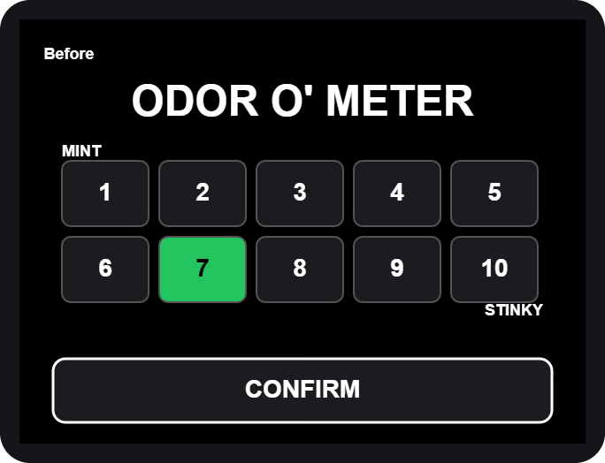  Rating grid: tap a box 1-10, then CONFIRM | 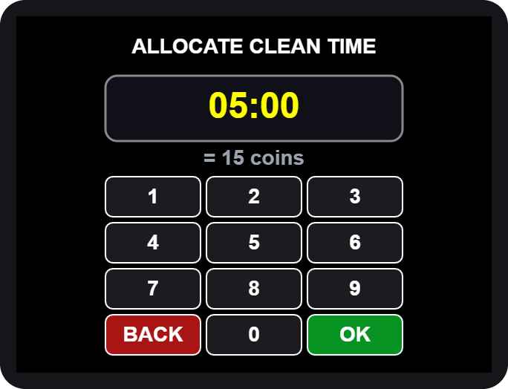  Number pad: type the minutes and seconds, then OK

- Big words (yellow) tell you what to do next: OPEN, PLACE, CLOSE, TAKE.
- Buttons are the dark boxes with white words. Tap them once.
- The screen blinks briefly now and then. This is normal, it refreshes itself.

Never put your hand in while the machine runs. If you open the door, the machine pauses by itself.

Box 1 - Cleaner
  1. Tap anywhere to START | 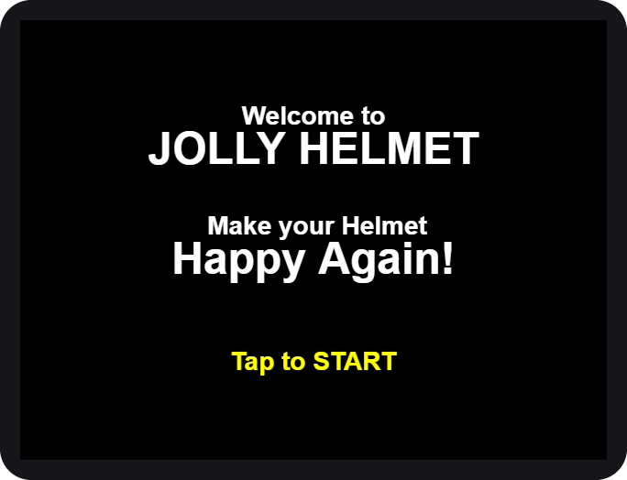  2. Welcome

- Wake the machine. Tap anywhere on the screen. For a moment it says "Please Wait" while it checks its alcohol and scented liquid.
- Tap to START on the welcome screen.

If the screen says OUT OF ORDER, the station needs refilling or service. Please tell the staff.

Rate it and choose the mist
3. ODOR O' METER | 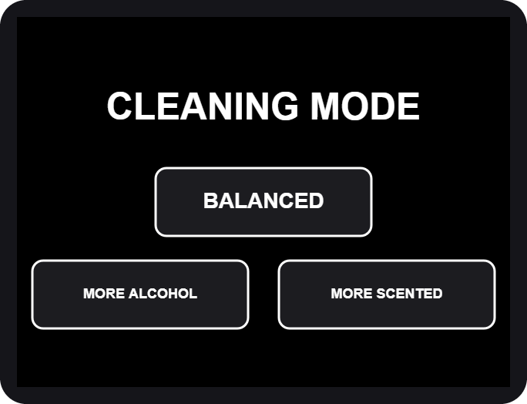  4. CLEANING MODE

- Rate the smell. Tap 1 (MINT, fresh) to 10 (STINKY), then CONFIRM. The worse the smell, the more time we suggest.
- Choose the mist. BALANCED uses both liquids, MORE ALCOHOL is stronger against germs, MORE SCENTED leaves a fresher scent.

Pick the time and pay
5. ALLOCATE CLEAN TIME | 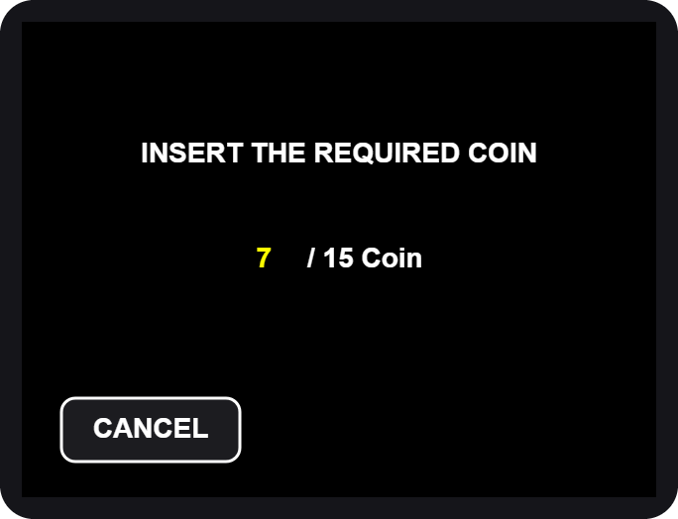  6. INSERT THE REQUIRED COIN

- Allocate time. The pad shows the time we suggest for your rating. Type a different time if you like, then tap OK. The shortest time and the longest time are shown if you go outside them.
- Insert the coins. The screen counts up: coins inserted / coins required. When it is enough, the machine moves on by itself.

Extra coins beyond the price give no extra time and are not refunded. Tap CANCEL before paying if you change your mind.

Load your helmet
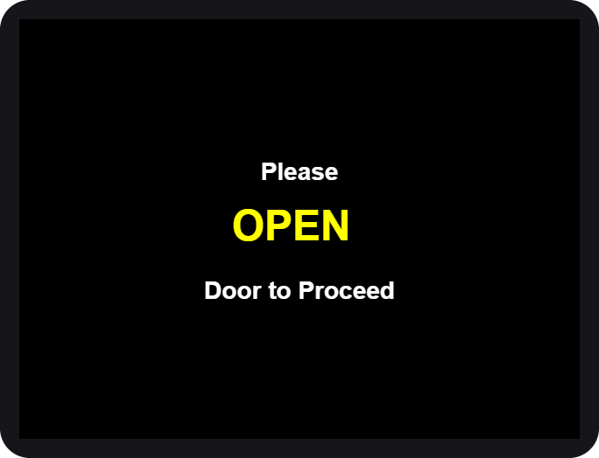  7. OPEN | 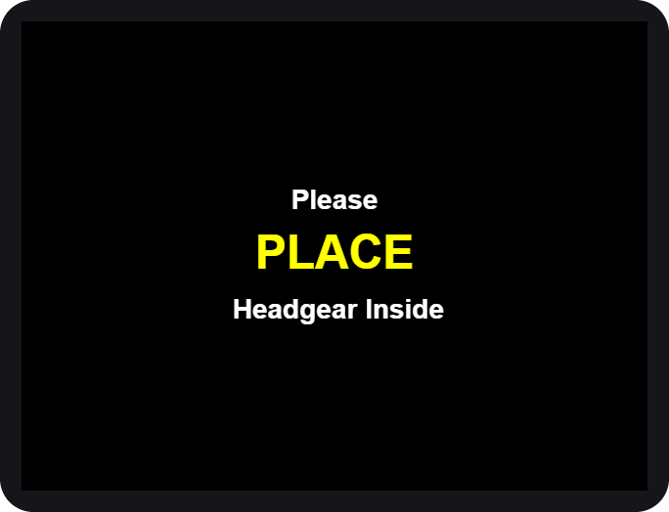  8. PLACE | 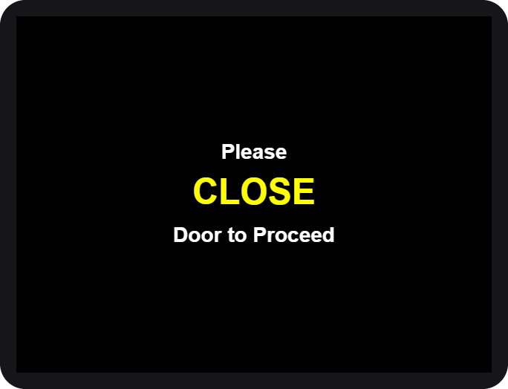  9. CLOSE

- OPEN the door when the screen asks.
- PLACE your helmet inside, opening facing the front, then step back.
- CLOSE the door. The machine checks that the door is shut and the helmet is inside, then starts.

If you see HELMET NO DETECTED, the machine did not see your helmet. Open the door and place it again.

While it cleans
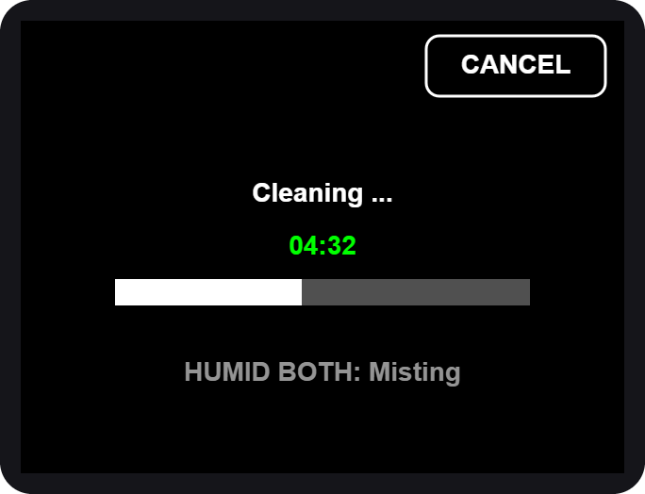  10. Cleaning... time left | 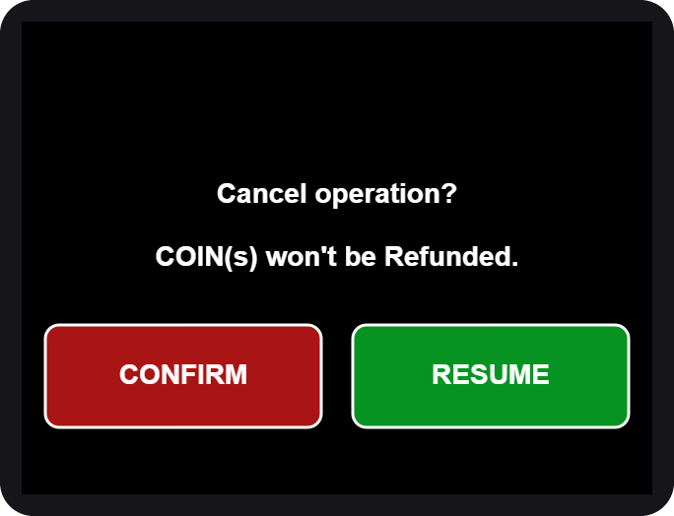  CANCEL asks first

- The big green number is the time left. The bar fills as it goes.
- The small grey line shows what is on: the mist, the UV light.
- To stop early tap CANCEL, then CONFIRM. Coins are not refunded. RESUME keeps cleaning.

If the door is opened during a run, everything pauses (SAFETY PAUSE). Close the door and it continues where it stopped.

All done
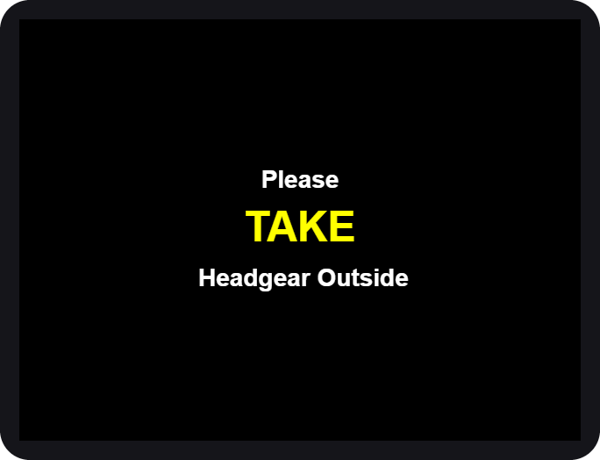  11. TAKE your helmet | 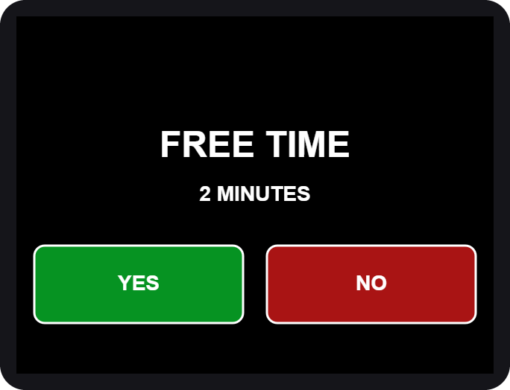  13. FREE TIME?

- OPEN the door and TAKE your helmet. Close the door again.
- Rate it again on the same 1-10 grid, then CONFIRM.
- Free retry. Not happy yet? The machine may offer a short FREE TIME (2 minutes). Tap YES to run once more, or NO. It is offered once per visit.
- The screen thanks you and returns to the start.

Box 2 - Dryer
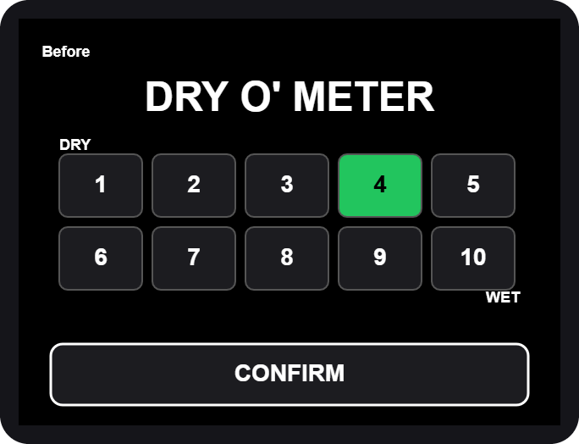  DRY O' METER | 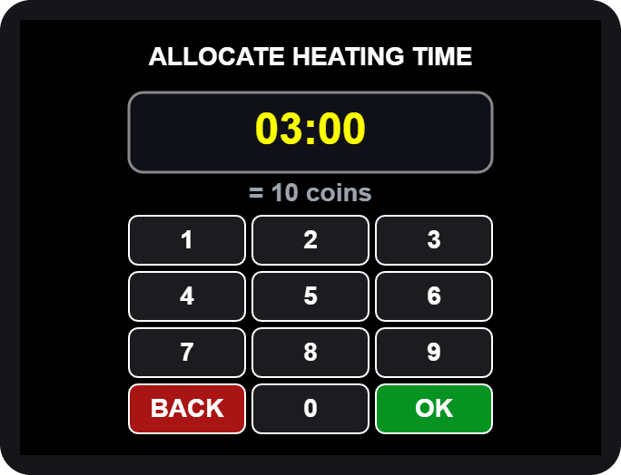  ALLOCATE HEATING TIME

- Tap anywhere, then Tap to START (same as Box 1).
- Rate how wet it is: 1 = DRY ... 10 = WET, then CONFIRM.
- Allocate heating time on the number pad, then OK.
- Insert the coins shown on the screen.
- OPEN, PLACE, CLOSE the door, same as Box 1.

Heating and cooling
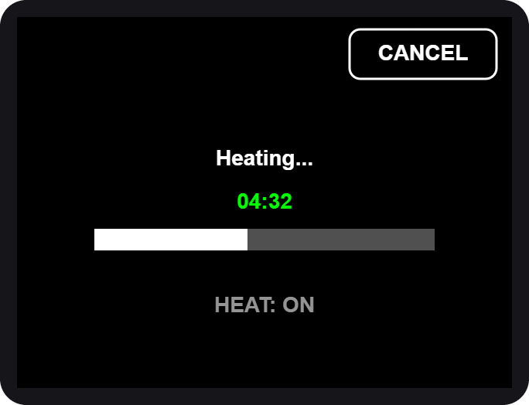  6. Heating... | 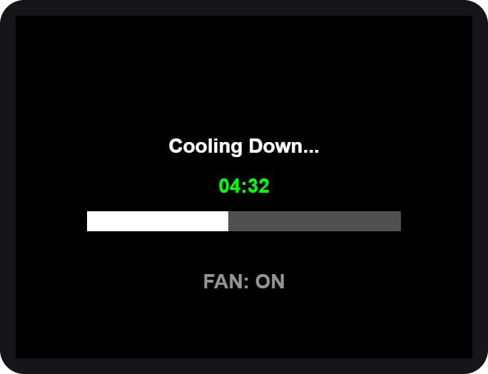  7. Cooling Down...

- Heating. Warm air dries the helmet and UV light freshens it. You can CANCEL, but coins are not refunded.
- Cooling down. A fan runs alone so the helmet is not hot to wear. The door stays locked until it ends.
- OPEN the door, TAKE your helmet, CLOSE the door.
- Rate it again, then use the free retry if you want one.

If you cancel while heating, the machine still cools the helmet down first, for your safety.

Box 3 - Cleaner + Dryer
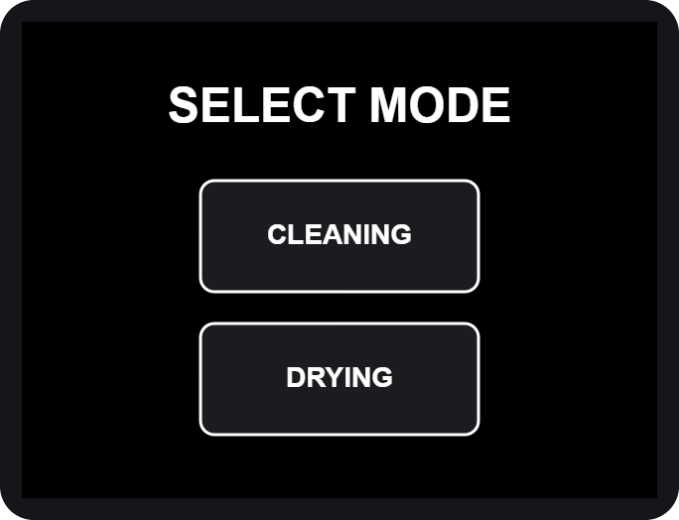  SELECT MODE | 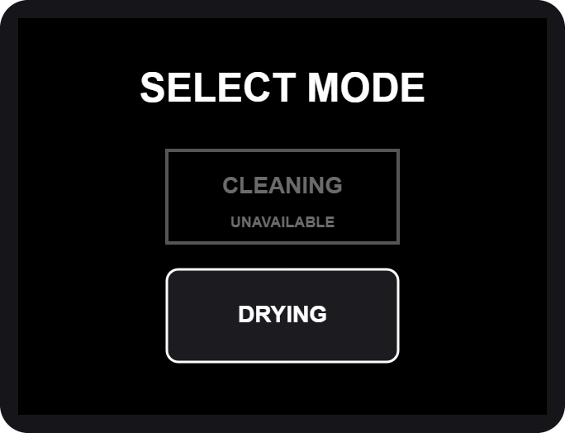  CLEANING unavailable

- Tap anywhere, then Tap to START.
- SELECT MODE. Tap CLEANING or DRYING.

If CLEANING is grey and says UNAVAILABLE, the cleaning liquids are being refilled or are low. DRYING still works.

CLEANING mode
Same steps as Box 1: rate the odor, choose the mist, pick the time, pay, load the helmet. At the end you rate two things: how dry it is, then how it smells. The heater runs only in the last minute, together with the UV light.

DRYING mode
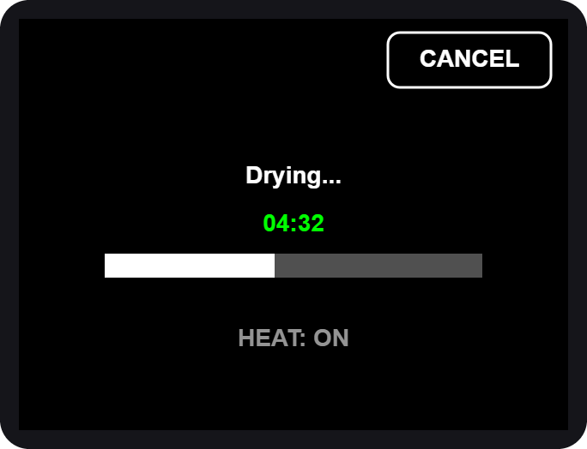  Drying... | 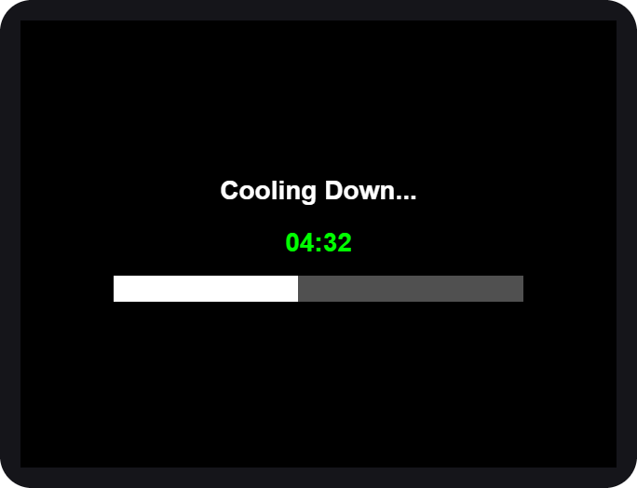  Cooling Down...

- Rate how wet the helmet is (DRY O' METER), then CONFIRM.
- Allocate drying time on the number pad.
- Pay, then OPEN, PLACE, CLOSE.
- Drying uses warm air and UV light. After it, the machine cools down for about a minute with nothing running.
- OPEN, TAKE, CLOSE, rate again and use the free retry if offered. A free retry after cleaning is another cleaning; after drying it is another drying.

Prices and time
Box 1 and Box 3 (cleaning): 15 coins = 5 minutes.

Rating | Suggested time | Coins
1 - 5 | 5 minutes | 15
6 - 7 | 10 minutes | 30
8 - 9 | 15 minutes | 45
10 | 20 minutes | 60

Longest session: 30 minutes (90 coins).
Box 2 (drying): 10 coins = 3 minutes.

Rating | Suggested time | Coins (about)
1 - 3 | 3 minutes | 10
4 - 6 | 5 minutes | 17
7 - 8 | 8 minutes | 27
9 - 10 | 10 minutes | 34

These are the starting prices. The admin can change them, so always check the INSERT THE REQUIRED COIN screen for the exact amount.

Special screens and safety

Special screens
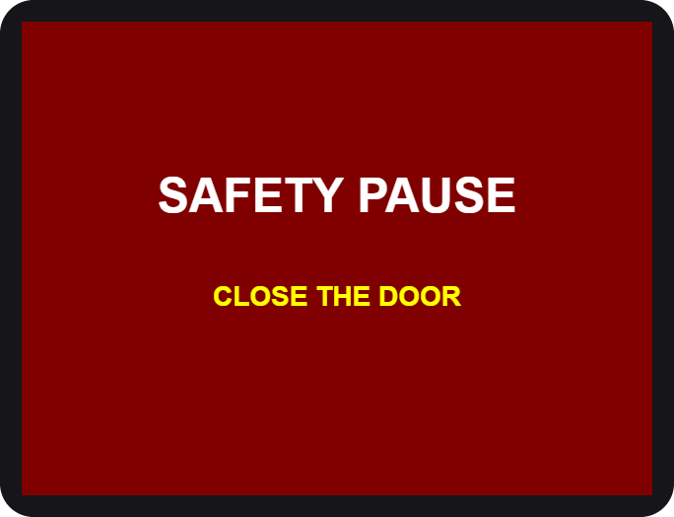  Door opened during a run |   Station needs service

You see | What it means / what to do
SAFETY PAUSE | The door was opened. Close it and the run continues.
HELMET NO DETECTED | No helmet seen. Open the door and place it again.
OUT OF ORDER | The station cannot work now. Use another station and tell the staff.
CLEANING UNAVAILABLE | Cleaning liquids are low. Use DRYING or come back later.
MAINTENANCE | A technician is working on the station.

Safety first
- Helmets only. Do not put bags, gloves, liquids or anything else inside.
- Keep your hands out while the machine runs. Hot air and UV light are used.
- UV light is strong. Never look into the chamber while it is on. The door must be closed.
- Do not force the door. It is locked on purpose while the machine runs. To stop, use CANCEL on the screen.
- Remove your helmet's accessories (camera, speaker, visor tint film) if they are not heat-safe.
- Children should use the machine with an adult.
- In an emergency, tap CANCEL, then CONFIRM. The machine stops and the door unlocks (on the dryers after a short cool-down).

If a helmet is stuck because of a power cut, the door unlocks by itself after a short while. Do not pull on it.

Questions

Question | Answer
The screen went white. | Wait a moment, it restarts itself. If it stays white, tell the staff.
I inserted a coin but nothing changed. | Insert the coin again slowly. Tell the staff if the count does not move.
Can I get a refund? | Coins are not refunded after the run has started or been cancelled.
The time is too long / too short. | On the number pad, type the time you want before tapping OK.
Why was I offered a free retry? | Because the helmet may need one more round. It is offered once per visit.
Which station should I use? | Smelly: Box 1 or Box 3 CLEANING. Wet: Box 2 or Box 3 DRYING.

Admin guide (Control Center)
The Control Center: settings, calibration and maintenance
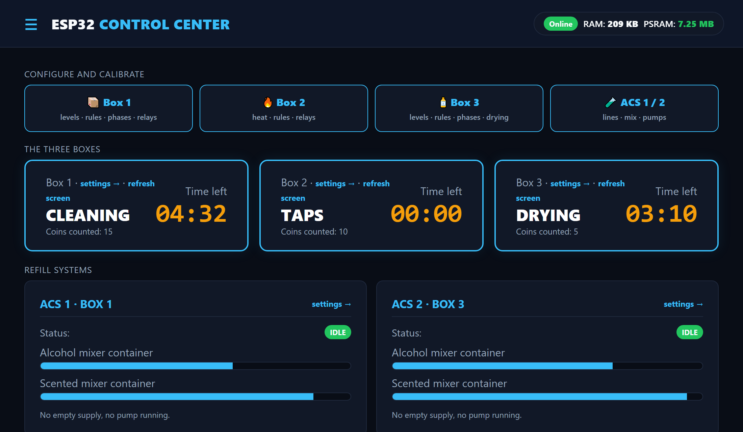
WEB PANEL FOR ADMINS AND TECHNICIANS

Connecting
The Control Center is a small web server (the LocalServer) inside the machine. You connect to it with a phone or laptop. It does not need internet.
- Switch on the machine and wait about 30 seconds.
- On your phone, join the Wi-Fi ESP32_LOCAL, password 12345678.
- Open a browser and go to http://192.168.4.1 (the page often opens by itself).
- The Home page appears. Use the menu button (three lines, top left) to open the settings pages.

The machines keep running and keep every setting even when the LocalServer is off or being replaced. It only shows, and sends your changes.

The Wi-Fi password is printed here for admins. Change it in the LocalServer program if this manual is shared outside the team.

Home page
- Alert banner (red): empty supplies, low mixers, a station out of order.
- Configure and calibrate: big buttons to Box 1, Box 2, Box 3 and ACS.
- The three boxes: current step, coins counted, time left, plus settings and refresh screen links.
- Refill systems: ACS status, mixer levels, empty or running pumps.
- Statistics: users served, revenue, average time, coins, last 10 cycles.
- Menu list: online/offline badge for every board.

Box settings (rules, levels, phases)

Rules and prices
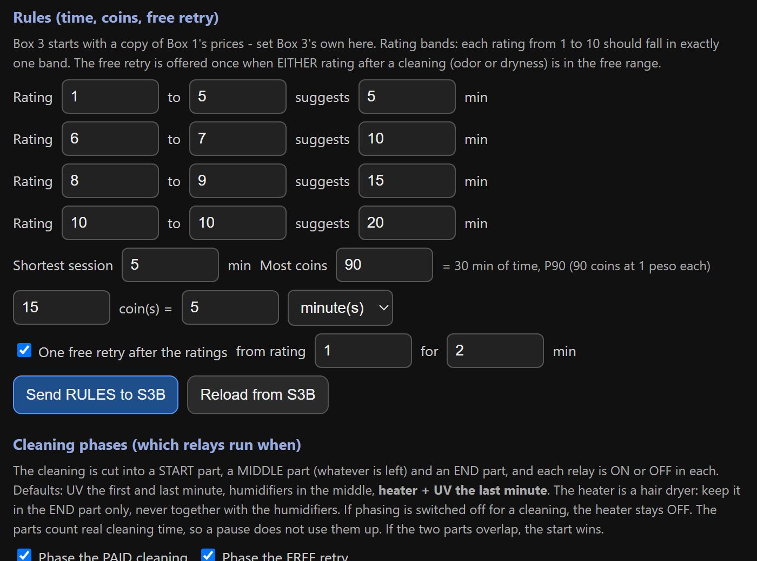
How to use it (Box 1, Box 2 and Box 3 have the same section):
- Open the box page, scroll to Rules.
- Set the rating bands (which ratings suggest how many minutes), the shortest session, the most coins and the coin rate (N coins = X minutes).
- Set the free retry (from which rating, for how many minutes).
- Tap Send RULES. A green tick means the box has saved them.

Containers and sensors
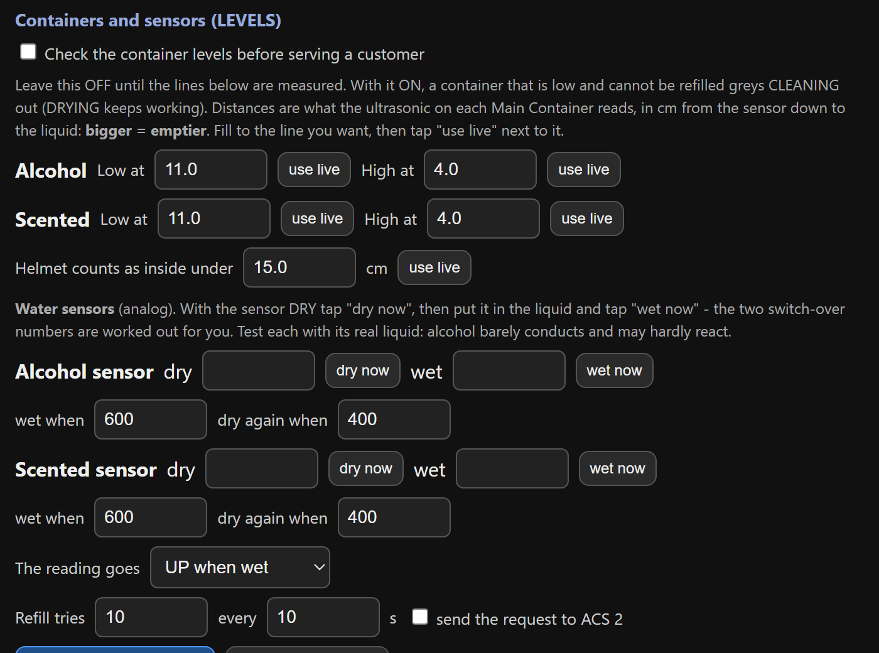
- Check the container levels: keep OFF until the numbers are measured.
- Low / High at: fill to the line, tap use live. Bigger number = emptier.
- Helmet inside under: put a helmet in, tap use live, raise it a little.
- Water sensors: dry now, then wet now in the real liquid (alcohol conducts poorly).
- Refill tries: tick send the request to the ACS only when the ACS works. Then tap Send LEVELS.

Cleaning phases
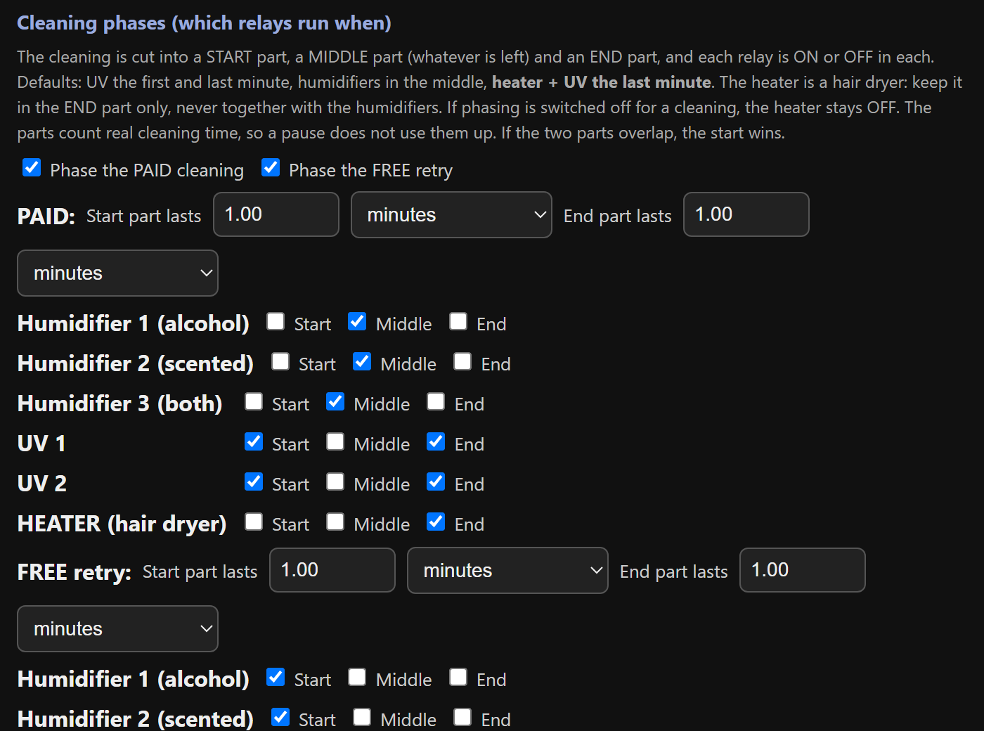
A cleaning is cut into a START part, a MIDDLE part and an END part. Tick when each relay is on.
- Example: UV on in Start and End, mist in the Middle.
- Always on = tick Start, Middle and End.
- Box 3: keep the HEATER in the End part only, never with a humidifier. The page warns you if they overlap.
- Paid cleaning and the free retry have their own tables.
Tap Send PHASES.

Heating and drying
- Box 2 - Heating: set the helmet distance (put a helmet in, use live) and the cool-down seconds (default 60, 5 to 900). Tap Send HEAT.
- Box 3 - Drying: set the cool-down seconds, then Send DRYING. The drying time itself comes from the customer's choice and the Rules.

Good to know
- Every setting is saved inside the box's own board, so it survives a power cut or a LocalServer replacement.
- If a number is outside its allowed range, the box refuses it. The green tick will not appear.
- Use Reload beside a Send button to bring back what the box really has.

Change one thing at a time and test it with a short session before leaving it.

Screen refresh and maintenance

Screen (touch display)
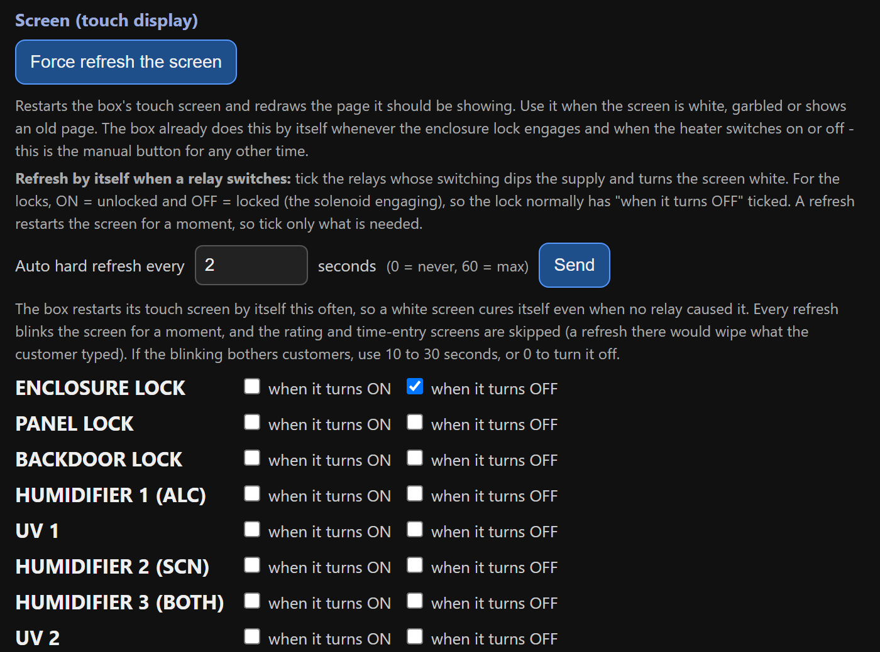
A heavy load switching on can make the touch screen go white. Three tools cure it:
- Force refresh the screen: restarts it now.
- Auto hard refresh every N seconds: restarts it by itself (0 = never, 60 = max). Rating and number-pad screens are skipped.
- Refresh when a relay switches: tick the relays (ON and/or OFF) that should trigger it. The lock is normally ticked OFF.

Maintenance mode
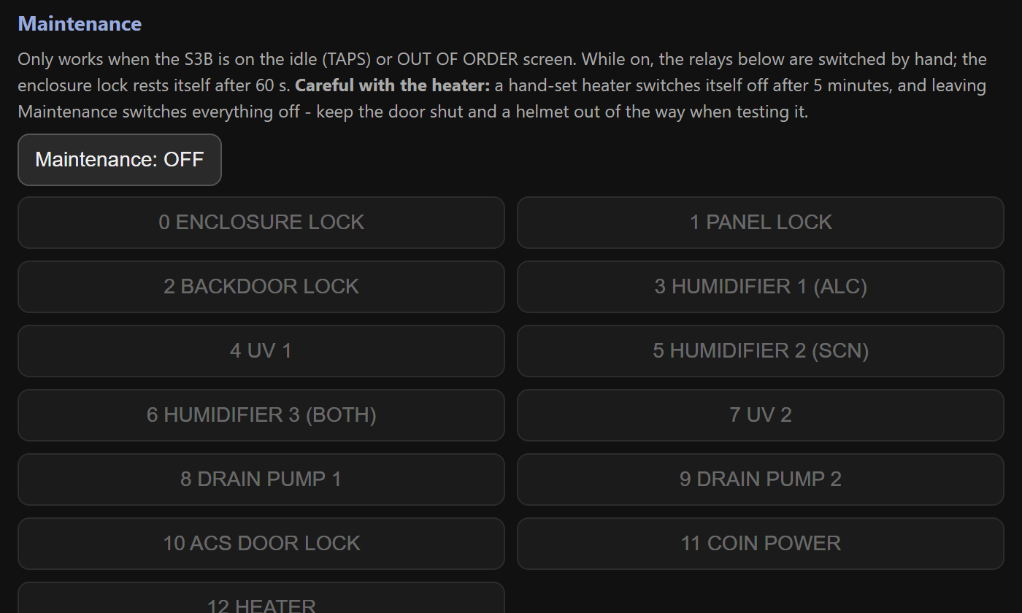
- Make sure the station is on its start screen (TAPS) or OUT OF ORDER.
- Tap Maintenance. The machine shows MAINTENANCE.
- Tap a relay button to switch it on or off by hand. Green = on.
- Tap Maintenance again. Everything switches off.

The hand-set heater turns itself off after 5 minutes and the lock after 60 seconds. Keep the door shut and clear when testing the heater.

Refill station (ACS)
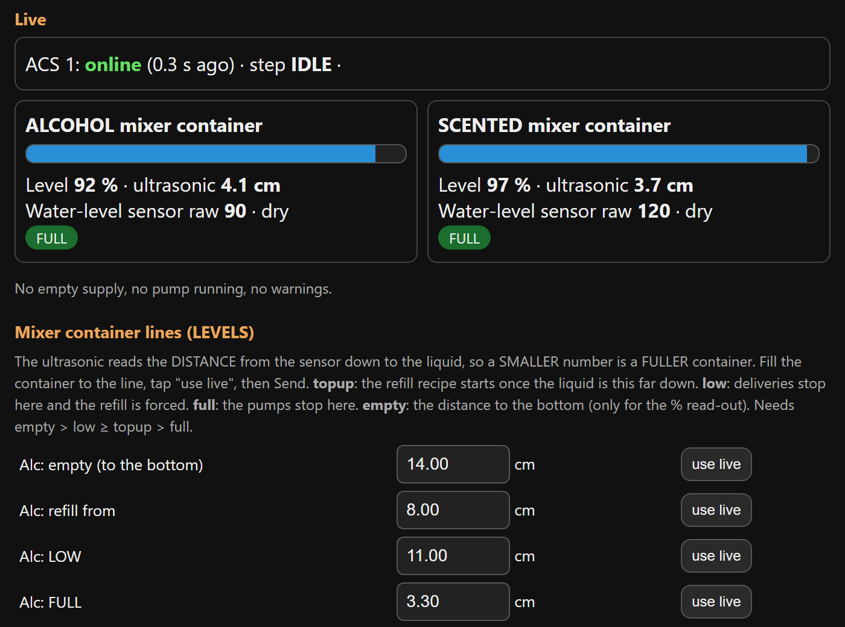
ACS 1 refills Box 1, ACS 2 refills Box 3. Each has three supply tanks (water, alcohol, scented), two mixer containers, and six pumps. Choose the ACS at the top of the page.
- When a mixer drops to its refill from line, the ACS adds water first, then the alcohol (or scented liquid) up to FULL.
- When a box asks, the matching mixer pump sends one short shot to the box.

Setting up the ACS
- Mixer container lines: fill each mixer to the line and tap use live for refill from, LOW, FULL and empty. Smaller number = fuller. Tap Send LEVELS.
- Mix: the water share of each top-up (30% water = 70/30 alcohol). Tap Send MIX.
- Timing / water-level sensors: use dry now / wet now for each sensor and Work out the thresholds. Tap Send TIMING.
- Check the pumps one at a time in Maintenance before the first automatic run.

Use plain water in all three supply tanks for the first test.

Reading the ACS

You see | It means
IDLE | Nothing to do. Mixers are above the refill line.
ALC WATER IN  ALC ALCOHOL IN | Filling the alcohol mixer: water, then alcohol.
SCT WATER IN  SCT SCENTED IN | Filling the scented mixer.
DELIVER ... | Sending one shot to the box.
WATER / ALCOHOL / SCENTED EMPTY | That supply tank is empty (or its pump is dead). The pump stopped and it retries in 5 minutes.
Half-made mix | A recipe was interrupted. The mixer is not delivered until it is finished.

Try it and fix it
- Ask: alcohol / scented pretends to be the box and makes one delivery shot. Stop cancels it.
- Retry now forgets an EMPTY verdict after you refilled a tank.
- Mixers are fine as they are clears the half-made flag when the mixers really hold good mix.
- Maintenance: run each of the six pumps by hand, one at a time. Each pump stops itself after 60 seconds.

Refilling a supply tank
- The three supply tanks have no sensors: look at them during your daily check.
- Refill the tank that is low or reported EMPTY.
- Tap Retry now.

Never run a pump dry. If liquid does not move when a pump runs, check the tube and the relay wiring first.

Troubleshooting and care

Troubleshooting

Problem | What to do
Screen white or garbled | Box page, Force refresh the screen. If it returns, tick the relay that causes it or lower the auto-refresh time.
A board shows OFFLINE | Check its power and wiring, then watch its badge on Home.
Station shows OUT OF ORDER | One board is silent (sensor or relay board). See the offline badges.
CLEANING is UNAVAILABLE | Containers are low. Check the ACS; refill, then Retry now.
Coins not counted | Use the coin check on the box page: pulses should rise by the coin's value.
Touch is off or upside down | The terminal needs its touch calibration or rotation checked.
Home says last restart BROWNOUT | Power dipped. Use a stronger supply and a short cable.

Care and spare parts

Daily check
- Home page: every badge ONLINE, no red banner.
- Look at the three ACS supply tanks (they have no sensors).
- Check the revenue and the number of users.

When a board breaks
- Keep one spare ESP32 per role, flashed and labelled (A1, S3B, ACS 2...).
- Swap it in and wire it exactly like the old one.
- Watch its badge turn ONLINE on Home, then re-enter that box's settings if they were lost.
- After rewiring, test each relay or pump by hand in Maintenance first.

S3A, S3B, S3C and the LocalServer are ESP32-S3 boards (16 MB, OPI PSRAM). The relay boards A3 and B3 must be plain ESP32 boards.

Thank you for using
Jolly Helmet
We hope to see you again!
Make your Helmet Happy Again.
MEJEZ STUDIO
[School / contact details here]
[Email or phone number here]
USER MANUAL

